**SESSION 5**

**Using FHIR in JavaScript Web Apps**

**INSTRUCTIONS**

• READ THIS DOCUMENT

• STOP AND EXPLORE CONTENT AT THE EMBEDDED LINKS

• ANSWER THE QUESTIONS

**TABLE OF CONTENTS**

A. BACKGROUND 2

B. WHAT DO JAVASCRIPT APPS DO 2

C. HOW DO YOU DOWNLOAD NODE.JS 2

D. HOW DO YOU INSTALL JS PACKAGES 2

E. HOW DO YOU CONNECT THE JS APP TO A FHIR SERVER IN IOL 4

F. HOW DO YOU DISPLAY RAW TEXT IN A BROWSER 5

G. HOW DO YOU DISPLAY FORMATED PATIENT INFORMATION IN A BROWSER 5

H. QUESTIONS 7

### **BACKGROUND**

For FHIR data to become truly useful, apps need to generate and consume these data and also do interesting and helpful things with these data. For example, imagine and app that can get your latest lab results for you and use those results to advise you about your diet and exercise regimen. This session will begin to show you how apps use FHIR data resources.

### **B. WHAT DO JAVASCRIPT APPS DO?**

JavaScript (JS) is a programming language used in developing mobile applications and web pages. JS allows developers to create frameworks and web pages that interact with servers like the Interoperability Land. JS is used in front-end and back-end web development. JS apps allow users to interact with web pages and mobile applications.

### **C. HOW DO YOU DOWNLOAD NODE.JS ?**

To complete this worksheet, you will need to download and install some software. The first thing to download is called Node.js. Node.js will allow you to run JavaScript from the command line of your computer.

Step 1: To download Node.js go to <https://nodejs.org/en/download/> and download the appropriate Long Term Support (LTS) version of Node.js for your PCs operating system.

Step 2: Create a new folder for this work. Move the Node.js software you just downloaded to the new folder.

Step 2: Install Node.js on your computer from within the new folder you created at Step 2.

### **D. HOW DO YOU INSTALL ADDITIONAL JS PACKAGES LOCALLY?**

To complete this worksheet, besides having Node.js, you must install some additional software packages for the app you will use to run.

The first thing to do, is to install the node package manager (npm). It will make it easier to install the rest of the JS packages locally:

Step 1: Open the command line on your computer.

Step 2: Change the folder (or directory) at the command line so that you are in the folder where you installed Node.js above.

HINT: If you are unfamiliar with the command line interface for your computer, you can search using your browser and the internet to learn how to use it.

Step 3: To install the latest version of npm, type the command below in the command line and hit return.

,,,,,,,,,,,,,,,,,,,,,,,,,,,,,,,,,

npm install -g npm

‘’’’’’’’’’’’’’’’’’’’’’’’’’’’’’’’’

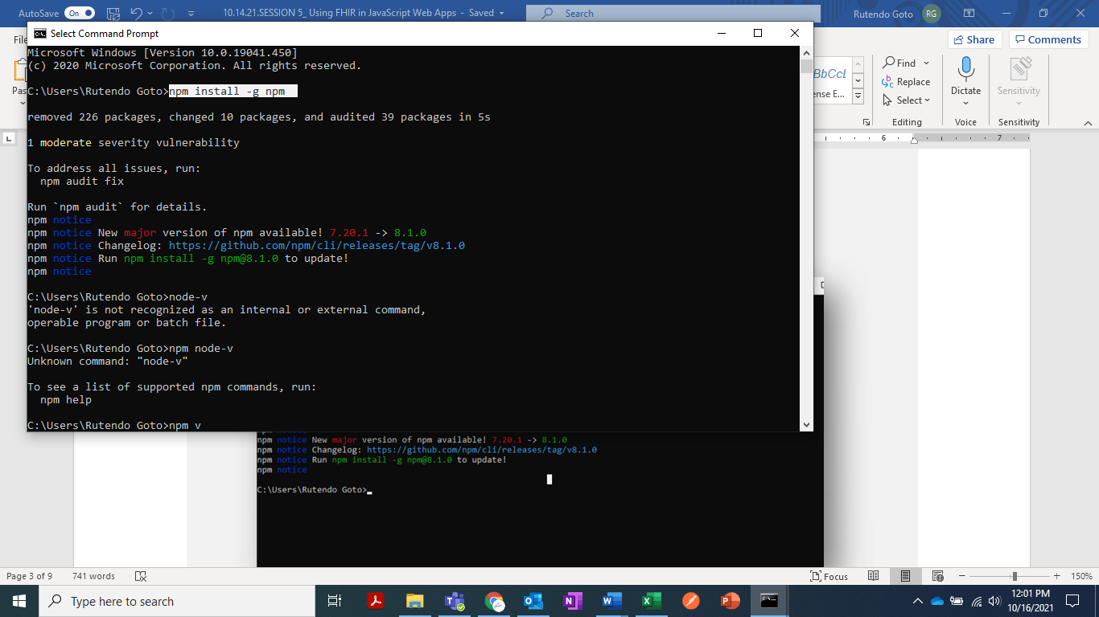

Step 3: To check if you have installed Node.js and see the version run the command below

,,,,,,,,,,,,,

node -v

‘’’’’’’’’’’’

Step 4: To check if you installed npm and see the version run the command below.

,,,,,,,,,,,,,

npm -v

‘’’’’’’’’’’’

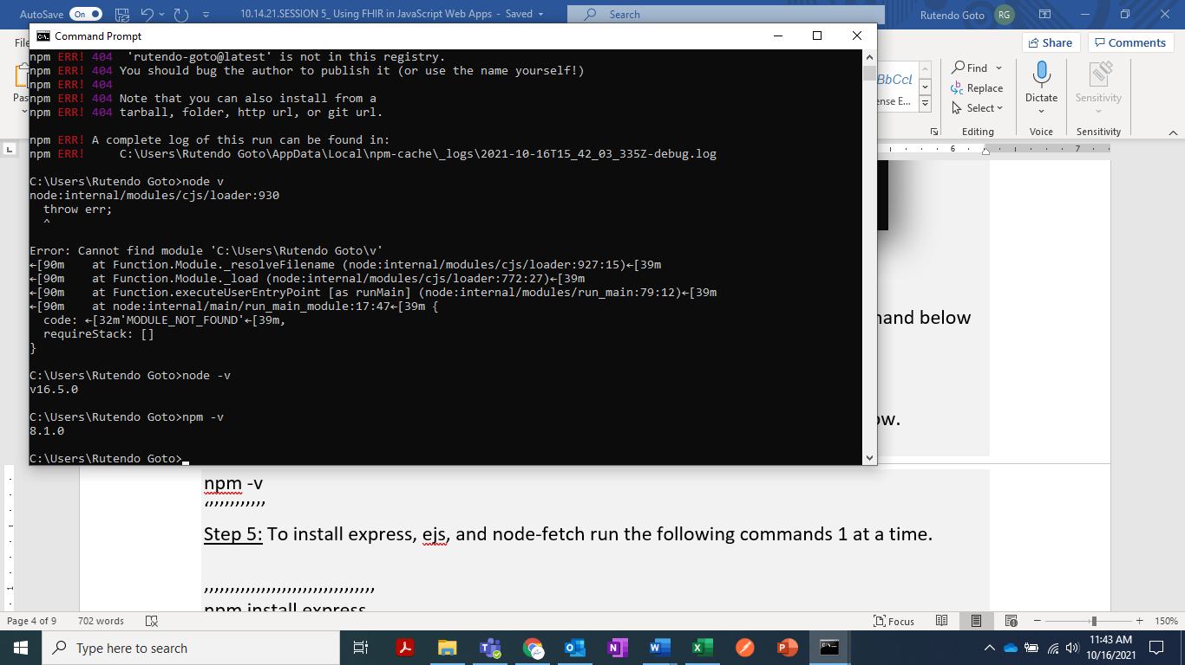

Step 5: To install express, copy and paste the following command to the command line and hit return

,,,,,,,,,,,,,,,,,,,,,,,,,,,,,,,,,

npm install express

‘’’’’’’’’’’’’’’’’’’’’’’’’’’’’’’’’

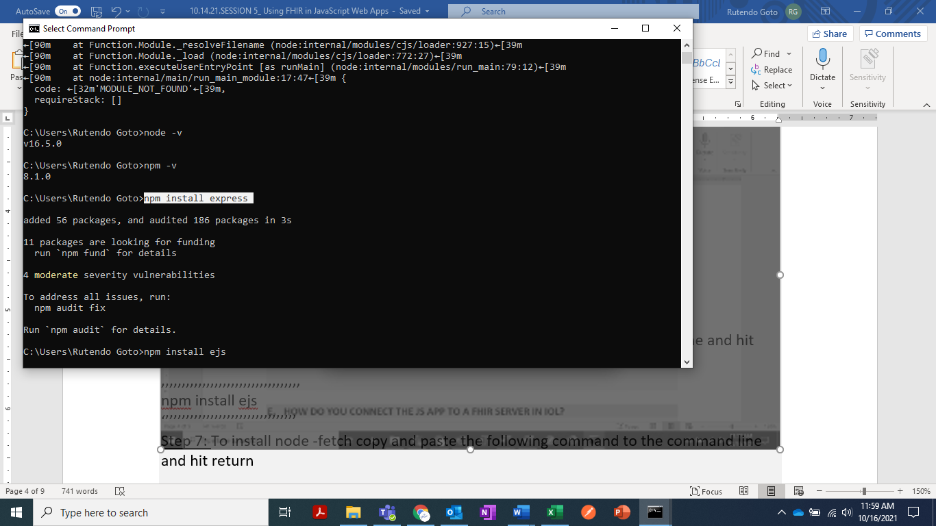

Step 6: To install ejs copy and paste the following command to the command line and hit return

,,,,,,,,,,,,,,,,,,,,,,,,,,,,,,,,,,

npm install ejs

‘’’’’’’’’’’’’’’’’’’’’’’’’’’’’’’’’

Step 7: To install node -fetch copy and paste the following command to the command line and hit return

,,,,,,,,,,,,,,,,,,,,,,,,,,,,,,,,,,,,,,,,,,,,,,,,,

npm install node-fetch@2.6.2

‘’’’’’’’’’’’’’’’’’’’’’’’’’’’’’’’’’’’’’’’’’’’’’’’’

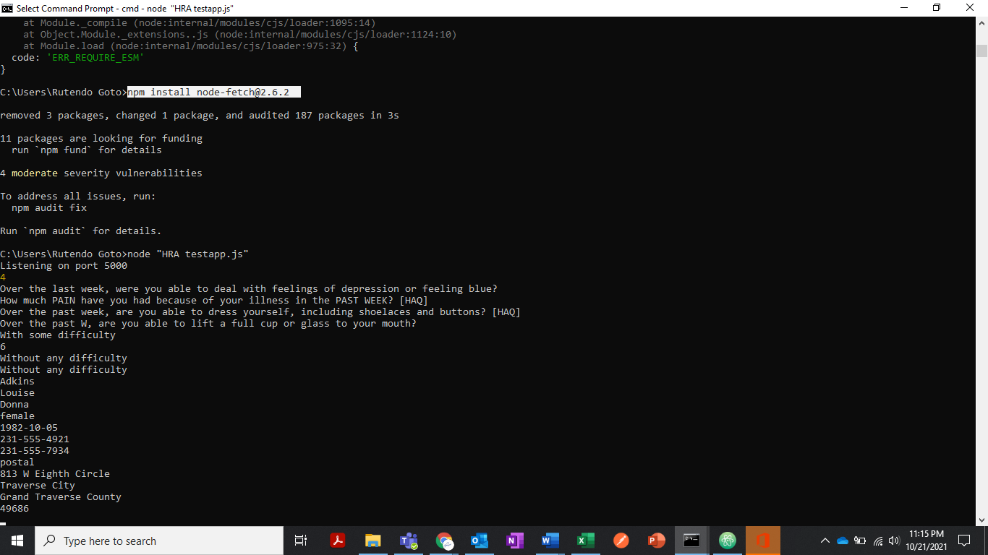

Note: to install node fetch you require a version 2 or prior, if you install anything after the node-fetch command will not work.

### **E. HOW DO YOU CONNECT THE JS APP TO A FHIR SERVER IN IOL?**

To connect a JS App to the FHIR server in IOL, follow these steps:

Step 1: Download and install atom go to <https://atom.io/>

Step 2: Open Atom and open a new file and save it as HRA testapp.js

Step 3: To access the code that connects to the IOL server open Github repository HRA-testapp go to <https://github.com/IOLCurriculum/IntroductoryCurriculum/tree/main/Session%205> and open the HRA testapp.js file

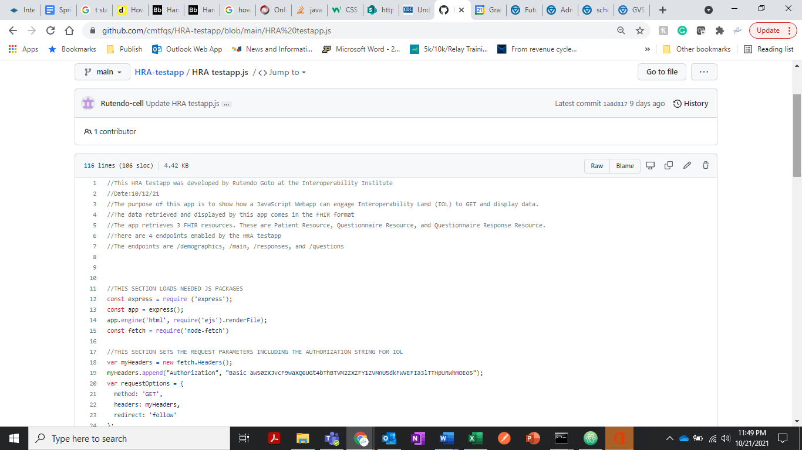

Step 4: Copy the code from HRA testapp.js file, paste it in your new Atom file, and save

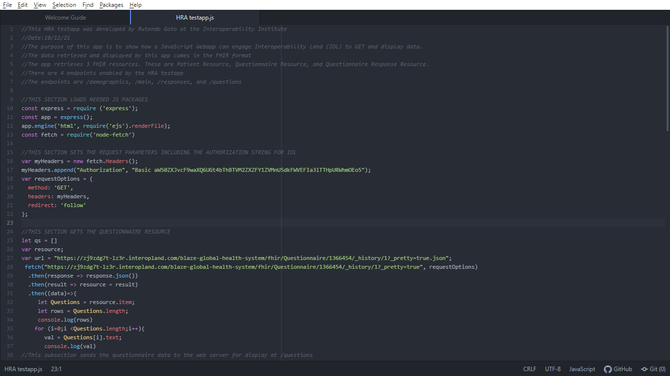

Step 5: To run the code, copy and paste the command below, with the double quotations

,,,,,,,,,,,,,,,,,,,,,,,,,,,,,,,,,,,,,

Node “HRA testapp.js”

‘’’’’’’’’’’’’’’’’’’’’’’’’’’’’’’’’’’’’

### **F. HOW DO YOU DISPLAY RAW TEXT IN A BROWSER**

To display raw information in a browser view , follow these steps:

Step 1: Open a new web browser page

Step 2: To view patient demographic information, input localhost:5000/demographics in the address bar and hit return to display the patient’s demographics

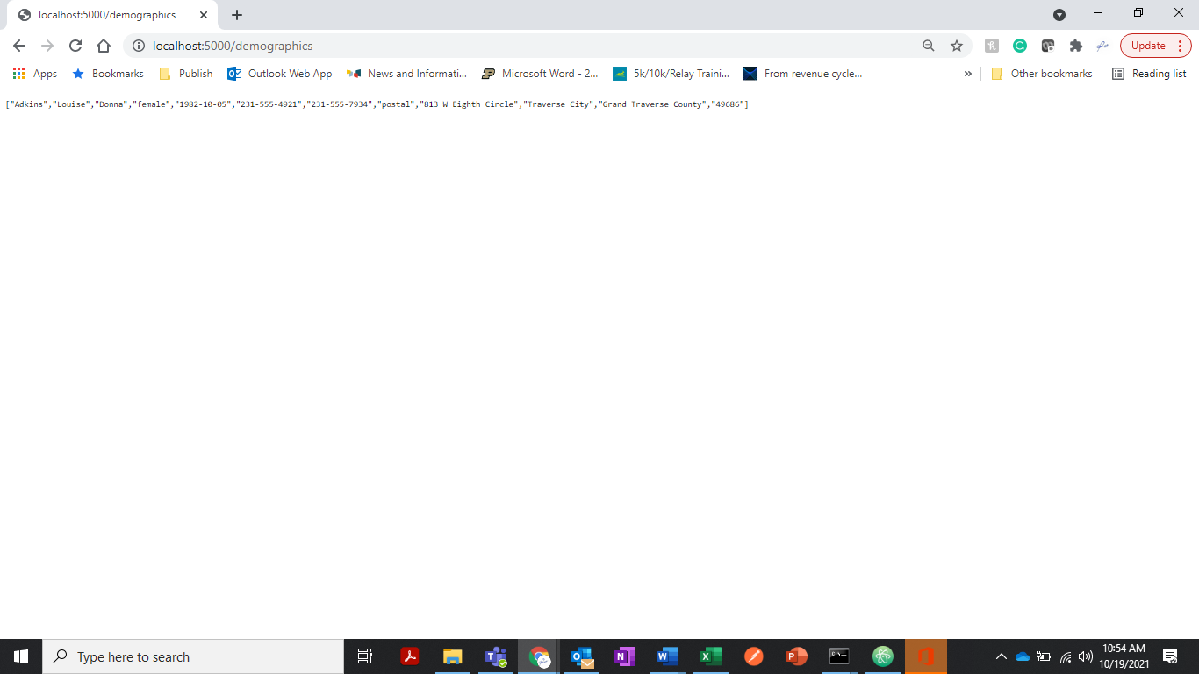

Step 3: To view the patient’s Questionnaire Responses in a browser copy and paste localhost:5000/responses in the address bar and hit return to display the responses

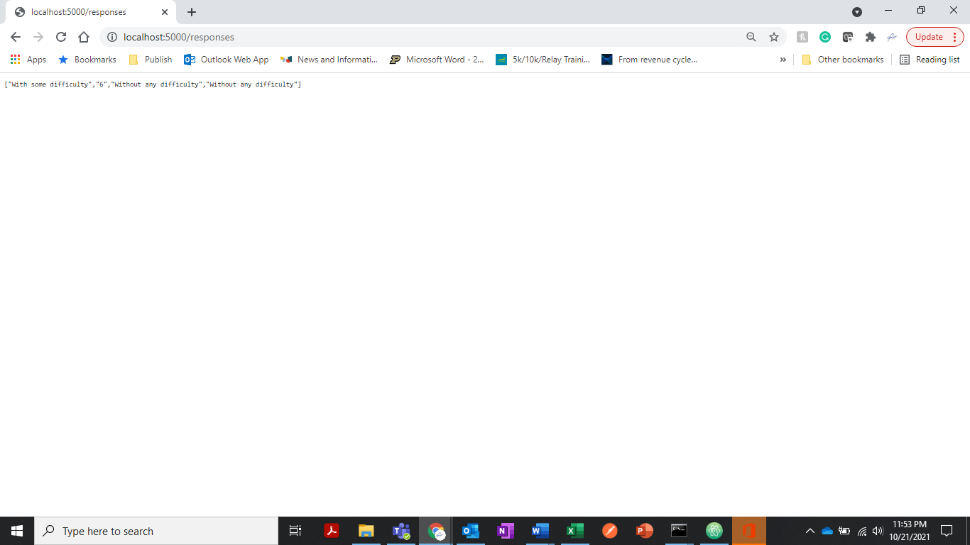

Step 4: To view the patient’s Questionnaire in a browser copy and paste localhost:5000/questions in the address bar and hit return to display the questions

### **G. HOW DO YOU DISPLAY FORMATED PATIENT INFORMATION IN A BROWSER?**

To display formatted information in a browser view , follow these steps:

Step 1: In Atom, create a new file and save it as main.HTML

Step 2: To access the code that formats the patient information open Github repository HRA-testapp, go to <https://github.com/cmtfqs/HRA-testapp> and open the main.HTML file

Step 3: Copy the code from main.HTML file, paste it in your new main.HTML file in Atom, and save

Step 4: In the command line enter ctrl + C to end the program

Step 5: To rerun the code, copy and paste the command below, with the double quotations

,,,,,,,,,,,,,,,,,,,,,,,,,,,,,,,,,,,,,

Node “HRA testapp.js”

‘’’’’’’’’’’’’’’’’’’’’’’’’’’’’’’’’’’’’

Step 6: To view formatted patient information, input localhost:5000/main and hit return

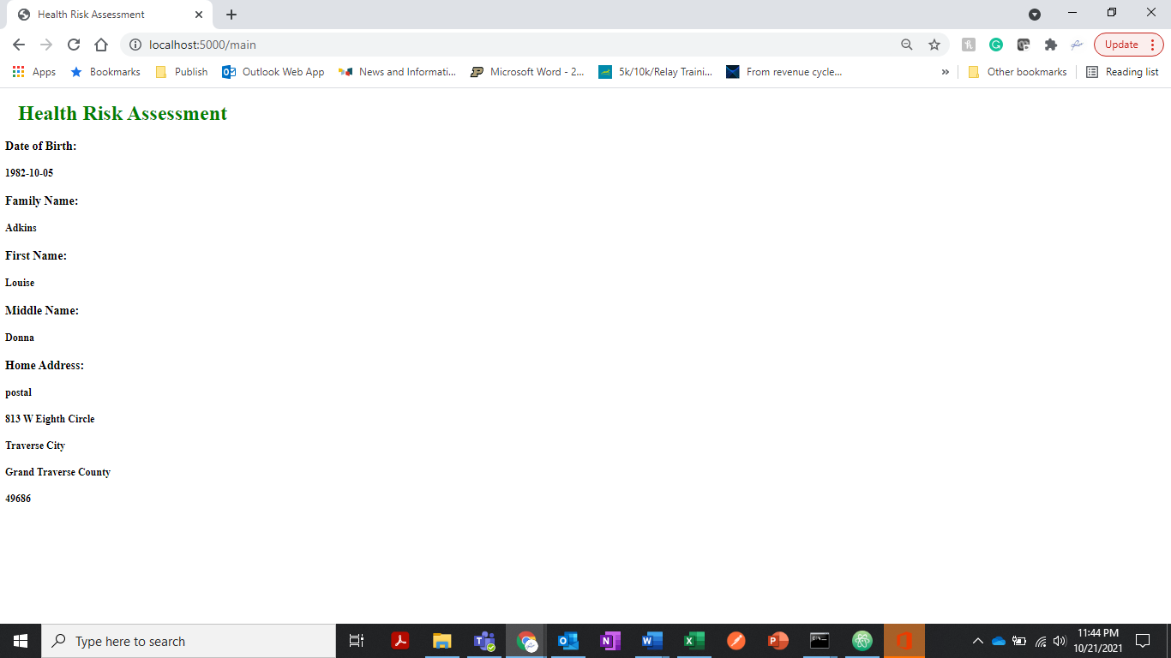

### **H. QUESTIONS TO TEST YOUR KNOWLEDGE**

1. What is Patient 166’s date of birth?

(Hint- Patient’s birthday is found in the demographics section)

**Your answer here**

1. What is the last question on the HRA questionnaire?

**Your answer here**